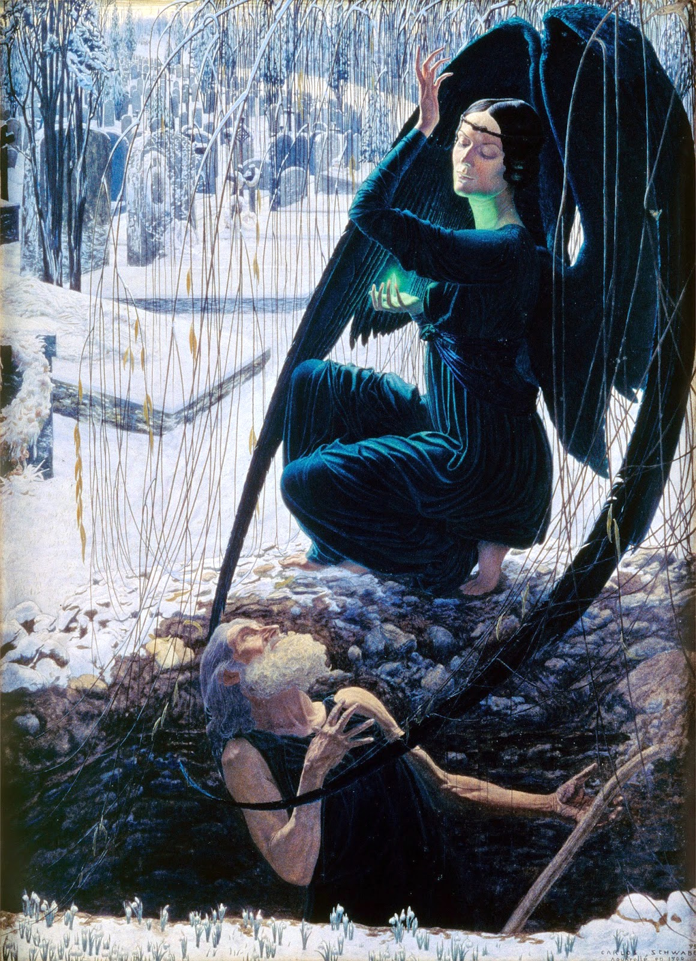
DISEASE, DEATH, DECAY
in Literatures, Cultures, and Languages
26-28 September 2016

CONFERENCE PROGRAMME

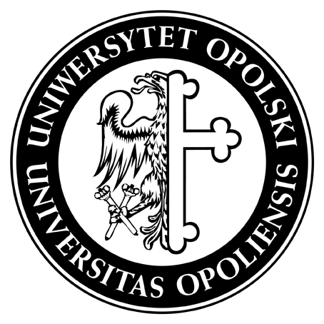
University of Opole
Institute of English,
Department of Anglophone Cultures

Carlos Schwabe, “Death of the Gravedigger” [La mort du fossoyeur], ca. 1890

MONDAY, 26 September 2016
11:00-12:00 REGISTRATION (Collegium Maius, pl. Kopernika 11)
12:00-12:15 OFFICIAL OPENING OF THE CONFERENCE / WELCOME ADDRESS
12:15-13:15 Plenary Lecture (Blue Lecture Theatre / Aula Błękitna)
- Tadeusz Sławek
- “Death is more than...”: On Death and Nudity
- Chair: Ryszard Wolny

13:15-14:30 LUNCH BREAK
Parallel sessions
SESSION 1 [room 207]  Literary explorations  Chair: Paweł Marcinkiewicz | SESSION 2 [room 208]  Film representations  Chair: Stankomir Nicieja
14:30-15:00  Dorisa D. Costello  Undead Corpse/Corpus: Textual Transmission and Butler’s Ek-static Subject in Le Fanu’s Carmilla | 14:30-15:00  Jacek Mydla  Death and Oblivion: the “Oedipal” Narrative in Psycho, Angel Heart and Shutter Island
15:00-15:30  Marek Błaszak  Decay, Disease and Death in Doris Lessing’s The Grass Is Singing | 15:00-15:30  Tomasz Fisiak  “I’ve Made you Ugly”: Decay, Disease and Death in What Ever Happened to Baby Jane?
15:30-16:00  Ryszard Wolny  Disease, Death and Decay as Exemplified by Daniel Defoe’s A Journal of the Plague Year (1722) | 15:30-16:00  Kamila Kalista  Love and Death or Laugh at Death? Presentation Based on ‘Love and Death’ (1975) by Woody Allen
16:00-16:30 COFFEE BREAK

MONDAY, 26 September 2016 // AFTERNOON SESSION
Parallel sessions
SESSION 1 [207]  Novel  Chair: Marek Błaszak | SESSION 2 [208]  Discourse and ideology  Chair: Katarzyna Molek-Kozakowska | SESSION 3 [207A]  Poetry  Chair: Tadeusz Lewandowski
16:30-17:00  Željka Babić  The Presence of the Professed Imminence in Borislav Pekić’s Rabies | 16:30-17:00  Daniel Broudy  Ideology as a Disease of the Mind Infecting a Dying Commons | 16:30-17:00  Przemysław Michalski  Death, Disintegration and Decay in the Poetry  of Roland Stuart Thomas
17:00-17:30  Marzena Kraszewska  Escape from Decay: The Cult of Youth  in Academic Novels | 17:00-17:30  Małgorzata Brożyna  Disease Metaphors in English and Polish Political Discourse | 17:00-17:30  Agata G. Handley  Disease, Demise and Dominance in the Poetry of Tony Harrison
17:30-18:00  Sławomir Kuźnicki  Rotting Melancholy: The False Utopia  of Kazuo Ishiguro’s The Buried Giant | 17:30-18:00  Joanna Gacka  Illness and Decay in Capitalist Classed  Societies: Blomkamp’s and Romanek’s Dystopian Visions | 17:30-18:00  Paweł Marcinkiewicz  Kenneth Goldsmith and The Body of Michael Brown
19:00-21:00 WELCOME RECEPTION
Villa Academica (Powstańców Śląskich 22)

TUESDAY, 27 September 2016 // MORNING SESSION
09:30-10:25 Plenary Lecture (Senate Chamber / Sala Senatu)
- Elżbieta Chrzanowska-Kluczewska
- The Taming of Death in Western and Eastern Tradition
- (Christianity vs. Tibetan Buddhism) as Reflected in Arts, Crafts and Sacred Texts
- Chair: Katarzyna Molek-Kozakowska

10:30-11:00 COFFEE BREAK
Parallel sessions
SESSION 1 [207]  Literary traditions  Chair: Tadeusz Sławek | SESSION 2 [208]  Language and dying  Chair: Elżbieta Chrzanowska-Kluczewska
11:00-11:30  Agnieszka Łowczanin  Death and Early Gothic Fiction | 11:00-11:30  Katarzyna Buczek  Levelling of i-umlaut in Classical and Post-classical Old Frisian
11:30-12:00  Marcin Tereszewski  Towards Inner Space: New Wave Science Fiction’s Debt to Gothic fiction | 11:30-12:00  Janusz Malak  From Where did the Death of the English Inflection Come?
12:00-12:30  Selin Yılmaz  Afterlife as Postmodern Time-space: Flann O’Brien’s The Third Policeman and Philip K. Dick’s Ubik | 12:00-12:30  Manel Herat  Child Epitaphs: A Diachronic Study from the Nineteenth Century  to the Present
12:30-13:00  Paulina Mirowska  Unburying the Dead: Sam Shepard’s Mature Work for the Stage | 12:30-13:00  Katarzyna Molek-Kozakowska  Framing Disease, Ageing and Death in Popular Science Journalism
13:00-14:30 LUNCH BREAK

TUESDAY, 27 September 2016 // AFTERNOON SESSION
14:30-15:25 Plenary Lecture (Senate Chamber / Sala Senatu)
- Jacek Fabiszak
- Death and Decay in Three Screen Versions of Shakespeare’s King Lear
- Chair: Tadeusz Sławek
15:30-16:00 COFFEE BREAK
Parallel sessions
SESSION 1 [207]  Grief and drama  Chair: Stankomir Nicieja | SESSION 2 [208]  Images of death and disease  Chair: Jacek Fabiszak
16:00-16:30  Katarzyna Małecka  “Is Grief a Disease?”: Perspectives on Bereavement in Modern Grief Memoirs | 16:00-16:30  Łucja Lange  An Attempt to Restore the Ordinary Death to the Visual Realm — Artistic, Therapeutic and Ethical Aspects of the Post-mortem Photography in the Twenty-first Century.
16:30-17:00  Stephen Dewsbury  Tramping the Dirt Down: The Real and Imagined Death of Margaret Thatcher | 16:30-17:00  Jamie A. Thomas  Talking About Zombies and Violent Death in the Time of Mexico’s Drug War
17:00-17:30  Wit Pietrzak  “I cannot thole the thought of Seamus Heaney dead”: Muldoon and the Endurance of Life | 17:00-17:30  Gregory S. Szarycz  Dis-Ease, Dis-Ability and Rehabilitation in Art and Culture: A Context for Understanding Health Tourism on the French Riviera through the Late Works of Pierre Auguste Renoir
17:30-18:00
Małgorzata Nitka
Death and the Railway

19:00-21:00 CONFERENCE DINNER
Szara Willa (Oleska 11)

WEDNESDAY, 28 September 2016 // Parallel sessions
SESSION 1 [207]  Dimensions of death in literature  Chair: Katarzyna Buczek | SESSION 2 [208]  Mortality/Immortality  Chair: Katarzyna Molek-Kozakowska
9:00-9:30  Fatma Gamze Erkan  The Question of Death and Life in Edgar Allan Poe’s “Morella” | 9:00-9:30  Aneta Kliszcz  Death of the Immortal
9:30-10:00  Ewa Wiśniewska  “Can a Dragon Cross the Wall of Stones?” The Perception of Afterlife in Ursula K. Le Guin’s Earthsea Cycle | 9:30-10:00  Magdalena Mączyńska  “[R]elease from the weariness of time” – on Death and Immortality in J. R. R. Tolkien’s Mythopoeia
10:00-10:30  Tomasz Gornat  “Once a year the dead live for one day”: Disease, Decay and Death in Malcolm Lowry's Under the Volcano | 10:00-10:30  Tadeusz Lewandowski  Dying to Save Lives: Zell Kravinsky and Lethal Organ Donation
10:30-11:00 Coffee break
SESSION 1 [207]  Culture and society  Chair: Tomasz Gornat | SESSION 2 [208]  History and rituals  Chair: Tadeusz Lewandowski
11:00-11:30  Marzena Keating  Eat, Drink, and Be Merry, for Tomorrow We Die: A Recipe for a Joyous Irish Wake | 11:00-11:30  Maciej Fatyga  Death and Legacy: Burials of Pharaohs of the First Phase of the 18th Dynasty.
11:30-12:00  Agnieszka Powierska  Animated Images of Mental Decay and Disorders | 11:30-12:00  Łukasz Fabia  Diseases in the Little Poland’s (Małopolska) Vitae (the Lives) and Miracula (the List of miracles) of the Saints in the 13th and 14th Centuries
12:00-12:30  Kamil Rusiłowicz  Absent Fathers, Postindustrial Landscapes, and American Cars: Ruin and Allegory in Philip Meyer’s American Rust | 12:00-12:30  Yogitha Shetty  Death and Life-after in Kōṭi-Chennaya Tradition
12:30-13:00  Andrzej Widota  Resurrecting a Dead Star: An Attempt at a Semantic Analysis of Lazarus by David Bowie | 12:30-13:00  Maciej H. Dąbrowski  Literary Descriptions of Death Pertaining to Blood Sacrifice in Augustan Poetry
13:00 CONFERENCE CLOSING [207]
13:45-15:00 Tour around the University Hill and the center of Opole

